AXIOMTEK Desktop uAPI Function User Guide
Document Re-Version: 001
- API Functions Calling Flow Chart
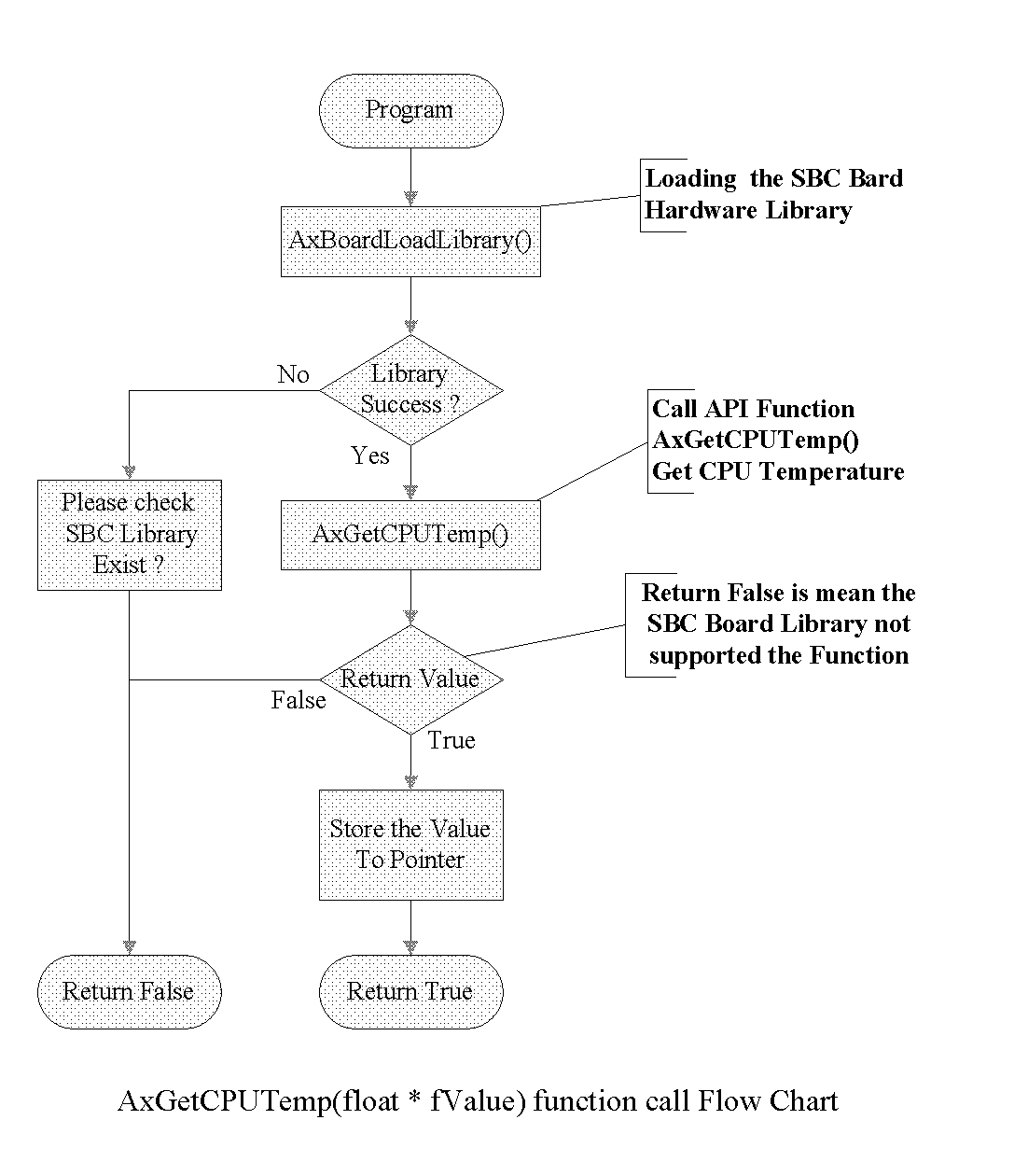
- API Function Call Description
SBC Library Control Group
BOOL AxBoardLoadLibrary(char *dllname)
Loading the library for SBC board
dllname : the SBC board library name
Return value : TURE or FALSE
BOOL AxBoardReleaseLibrary(void)
Release SBC board library
Return value : TURE or FALSE

Unique Board ID Group:
BOOL AxGetBoardID(SBC_DS2401* sbc_bid)
Get Unique Board ID used SBC_DS2401 Struct
Sbc_bid : the pointer of SBC_DS2401 for Board ID
Return value : TURE or FALSE
typedef struct SBC-DS2401 {
long double dlBoardID; // store long integer
unsigned char bBoardID; // store byte mode of value, BIOS Version
unsigned char sBoardID; // store string mode of value, Board ID
}sbc_ds2401;

Hardware Monitor Group
BOOL AxGetCPUTemp(float * fValue)
Get the current CPU temperature (C degree)
fValue : the pointer of reply data for CPU Temperature value
Return value : TURE or FALSE
BOOL AxGetSYSTemp(float *fValue)
Get the current SYSTEM temperature ( C degree)
fValue : the pointer of reply data for SYS Temperature value
Return value : TURE or FALSE
BOOL AxGetCPUFAN(float *fValue)
Get the current CPU FAN Speed (rpm)
fValue : the pointer of reply data for CPU FAN RPMs value
Return value : TURE or FALSE
BOO AxGetSYSFAN(float *fValue)
Get the current System FAN speed (rpm)
fValue : the pointer of reply data for SYS FAN RPMs value
Return value : TURE or FALSE
BOOL AxGetCPUVcore(float *fValue)
Get the current CPU Vcore voltage value
fValue : the pointer of reply data for CPU Vcore voltage value
Return value : TURE or FALSE
BOOL AxGetNBVTT(float *fValue)
Get North Bridge VTT voltage value
fValue : the pointer of reply data for VTT voltage value
Return value : TURE or FALSE

BOOL AxGet3V(float *fValue)
Get 3.3V voltage
fValue : the pointer of reply data for 3.3V voltage value
Return value : TURE or FALSE
BOOL AxGet5V(float *fValue)
Get 5V voltage
fValue : the pointer of reply data for 5V voltage value
Return value : TURE or FALSE
BOOL AxGet12V(float *fValaue)
Get 12V voltage
fValue : the pointer of reply data for 12V voltage value
Return value : TURE or FALSE
BOOL AxGetNeg5V(float *fValue)
Get -5V voltage
fValue : the pointer of reply data for Negative 5V voltage value
Return value : TURE or FALSE
BOOL AxGetNeg12V(float *fValue)
Get -12V voltage
fValue : the pointer of reply data for Negative 12V voltage value
Return value : TURE or FALSE
BOOL AxGetVbat(float *fValue)
Get Battery voltage
fValue : the pointer of reply data for battery backup voltage value
Return value : TURE or FALSE

Digital Input Output Group:
BOOL AxGetDI(int pin, int *pinData)
Get Digital input pin status
pin : can be set to multi pin access, bit0 -> 0x01, bit1 -> 0x02, ……
pinData : the reply status pointer for Digital input
Return value : TURE or FALSE
BOOL AxGetDO( int pin, int *pinData)
Get Digital Output pin status
pin : can be set to multi pin access, bit0 -> 0x01, bit1 -> 0x02, ……
pinData : the reply status pointer for Digital output
Return value : TURE or FALSE

BOOL AxSetDO(int pin, int *pinData)
Set Digital Output pin Status
pin : can be set to multi pin access, bit0 -> 0x01, bit1 -> 0x02, ……
pinData : the set output status pointer for Digital output
Return value : TURE or FALSE
BOOL AxGetDIOValidPin(int DIO, *pinData)
Get Digital Input Output Valid Pin Value
DIO : 1 → get DI valid pins , 2 → get DO valid pins others is failure
pinData : reply the DI/DO valid pins, bit0 → pin0, bit1 → pin1 , … …
Return value : TURE or FALSE
BOOL AxSetDIODirection(int pin, int *pinData)
Set Digital IO pins direction
pin: assign which pin to assign, bit# =1 is assigned configure
pinData: bit# = 0 → Output direction
bit# = 1 → Input direction
Return FALSE when the DIO could not be configure

Watch Dog Timer Group:
- BOOL AxWDTSetCounter(int timeCounter)
Set the Watch Dog Timer Down Counter value
timeCounter : High byte != 0 is Minute base, 0 is Second base
Low byte 0 ~ 255 counter value, 0 is disable counter
Return value : TURE or FALSE
- BOOL AxWDTexec(int subFunction)
Exec WDT sub function
subFunction : bWDT_ENABLE, bWDT_RELOAD, bWDT_DISABLE
Return value : TURE or FALSE
- BOOL AxWDTOutputPin(int subFunction)
Enable / Disable WDT Output ping single event
subFunction : bWDT_ENABLE, bWDT_DISABLE
Return value : TURE or FALSE
- BOOL AxWDTEvent(int subFunction, int *repData)
The WDT Event function
subFunction : bWDT_EVENT, bWDT_EVENT_CLR
*repData : store event flag for bWDT_EVENT command
return true for times up event occur by bWDT_EVENT

Utilities Function Group:
int AxOS_Version(void)
check the current Windows OS version
return -1 : unknown OS version
32bit system:
OS_WIN95 0x0001
OS_WIN98 0x0002
OS_WINME 0x0003
OS_WIN2000 0x0004
OS_WNNT 0x0005
OS_WINXP 0x0006
OS_VISTA 0x0007
OS_SERVER2003 0x0008
OS_WINDOWS7 0x0009
64bit system:
OS64_WINXP 0x0101
OS64_VISTA 0x0102
OS64_WINDOWS7 0x0103
BOOL AxSystemReboot(void)
Reboot the system
BOOL AxSystemShutdown(void)
Shutdown the system
BOOL AxSBC_BIOSID(char *biosid)
get the current SBC board BIOS ID string
biosid : the BIOS ID string data character pointer
Return value : TURE or FALSE

